**Student Name:- Chaudhary Hamdan**

**Student Roll No.:- 1905387**

**Algorithm Lab. Class Assignment-13**

**CSE Group 1**

**Date: - 29th October 2021**

1. Write a program to find Minimum Cost Spanning Tree of a given undirected graph using Kruskal's algorithm.

**Program**

// Author: Chaudhary Hamdan

// Generated at: Fri Oct 29 12:42:15 2021

#include <stdio.h>

#include <time.h>

#include <stdlib.h>

#define sf(x) scanf("%d", &x)

#define pf printf

#define pfs(x) printf("%d ", x)

#define pfn(x) printf("%d\n", x)

#define pfc(x) printf("%d, ", x)

#define FI(i,x,y,inc) for(int i = x; i < y; i += inc)

#define F(i,x,y) FI(i, x, y, 1)

#define F0(i,n) FI(i, 0, n, 1)

#define RF(i,x,y) for(int i = x; i >= y; i--)

#define pfarr(i,a,n) for(int i = 0; i < n-1; i++) pfs(a[i]); pfn(a[n-1]);

void i_o_from_file() {

#ifndef ONLINE_JUDGE

freopen("C:\\Users\\KIIT\\input", "r", stdin);

freopen("C:\\Users\\KIIT\\output", "w", stdout);

#endif

}

/* ********************************************** */

struct Edge {

int src, dest, weight;

};

struct Graph {

int V, E;

struct Edge* edge;

};

struct Graph* createGraph(int V, int E)

{

struct Graph* graph = (struct Graph*)(malloc(sizeof(struct Graph)));

graph->V = V;

graph->E = E;

graph->edge = (struct Edge*)malloc(sizeof(struct Edge) * E);

return graph;

}

struct subset {

int parent;

int rank;

};

int find(struct subset subsets[], int i)

{

if (subsets[i].parent != i)

subsets[i].parent

= find(subsets, subsets[i].parent);

return subsets[i].parent;

}

void Union(struct subset subsets[], int x, int y)

{

int xroot = find(subsets, x);

int yroot = find(subsets, y);

if (subsets[xroot].rank < subsets[yroot].rank)

subsets[xroot].parent = yroot;

else if (subsets[xroot].rank > subsets[yroot].rank)

subsets[yroot].parent = xroot;

else

{

subsets[yroot].parent = xroot;

subsets[xroot].rank++;

}

}

int myComp(const void* a, const void* b)

{

struct Edge* a1 = (struct Edge*)a;

struct Edge* b1 = (struct Edge*)b;

return a1->weight > b1->weight;

}

void KruskalMST(struct Graph* graph)

{

int V = graph->V;

struct Edge

result[V];

int e = 0;

int i = 0;

qsort(graph->edge, graph->E, sizeof(graph->edge[0]), myComp);

struct subset* subsets = (struct subset*)malloc(V * sizeof(struct subset));

for (int v = 0; v < V; ++v) {

subsets[v].parent = v;

subsets[v].rank = 0;

}

while (e < V - 1 && i < graph->E) {

struct Edge next_edge = graph->edge[i++];

int x = find(subsets, next_edge.src);

int y = find(subsets, next_edge.dest);

if (x != y) {

result[e++] = next_edge;

Union(subsets, x, y);

}

}

printf("Edges in MST:-\n");

int minimumCost = 0;

for (i = 0; i < e; ++i)

{

printf("%d -- %d == %d\n", result[i].src, result[i].dest, result[i].weight);

minimumCost += result[i].weight;

}

printf("\nMinimum Cost: %d", minimumCost);

return;

}

int main() {

i_o_from_file();

/* ********************************************* */

int V, E;

sf(V);

sf(E);

struct Graph* graph = createGraph(V, E);

F0(i, E) {

sf(graph->edge[i].src);

sf(graph->edge[i].dest);

sf(graph->edge[i].weight);

}

KruskalMST(graph);

return 0;

}

**Output**

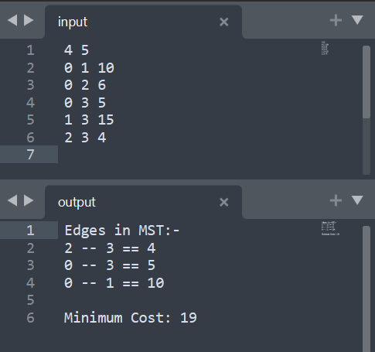

1. Write a program to find Minimum Cost Spanning Tree of a given undirected graph using Prims algorithm.

**Program**

// Author: Chaudhary Hamdan

// Generated at: Fri Oct 29 12:42:30 2021

#include <stdio.h>

#include <time.h>

#include <limits.h>

#include <stdbool.h>

#define sf(x) scanf("%d", &x)

#define pf printf

#define pfs(x) printf("%d ", x)

#define pfn(x) printf("%d\n", x)

#define pfc(x) printf("%d, ", x)

#define FI(i,x,y,inc) for(int i = x; i < y; i += inc)

#define F(i,x,y) FI(i, x, y, 1)

#define F0(i,n) FI(i, 0, n, 1)

#define RF(i,x,y) for(int i = x; i >= y; i--)

#define pfarr(i,a,n) for(int i = 0; i < n-1; i++) pfs(a[i]); pfn(a[n-1]);

void i_o_from_file() {

#ifndef ONLINE_JUDGE

freopen("C:\\Users\\KIIT\\input", "r", stdin);

freopen("C:\\Users\\KIIT\\output", "w", stdout);

#endif

}

/* **************************************************************** */

int V;

int minKey(int key[], bool mstSet[])

{

int min = INT_MAX, min_index;

for (int v = 0; v < V; v++) {

if (mstSet[v] == false && key[v] < min) {

min = key[v], min_index = v;

}

}

return min_index;

}

int printMST(int parent[], int graph[V][V])

{

printf("Edge \tWeight\n");

F(i, 1, V) {

printf("%d - %d \t%d \n", parent[i], i, graph[i][parent[i]]);

}

}

void primsMST(int graph[V][V])

{

int parent[V];

int key[V];

bool mstSet[V];

F0(i, V) {

key[i] = INT_MAX;

mstSet[i] = false;

}

key[0] = 0;

parent[0] = -1;

F0(cnt, V - 1) {

int u = minKey(key, mstSet);

mstSet[u] = true;

F0(v, V) {

if (graph[u][v] && mstSet[v] == false && graph[u][v] < key[v]) {

parent[v] = u;

key[v] = graph[u][v];

}

}

}

printMST(parent, graph);

}

int main() {

i_o_from_file();

/* ********************************************* */

sf(V);

int graph[V][V];

F0(i, V) {

F0(j, V) {

sf(graph[i][j]);

}

}

primsMST(graph);

return 0;

}

**Output**

